Student Computer Setup Guide for This Workshop
Setup Time: 45-60 minutes
Setup Overview: These setup instructions walk through the steps required to configure a Windows PC or a virtual machine (VM) that will be used by students when working on the lab exercises for the MBAS Preconference Workshop titled Power BI Dev-in-a-Day.

Install and Configure Windows 10 or Windows 8.1
In this step you will install the Windows operating system.
- Install the x64 bit edition of Windows.
  - You can install either Windows 10 or Windows 8.1 to complete lab exercises.
  - Apply all Windows updates.
- Install the Chrome browser.
  - You should be able to access the Internet with Chrome and at least one other browser (e.g. Edge, Internet Explorer).
- Enable the execution of PowerShell scripts on your local PC.
  - Open a PowerShell command shell running as Admin and type in and execute the following PowerShell command.
Set-ExecutionPolicy Bypass -Scope CurrentUser
  - When prompted to confirm to the operation, type Y and press ENTER to confirm that you want to enable script execution.
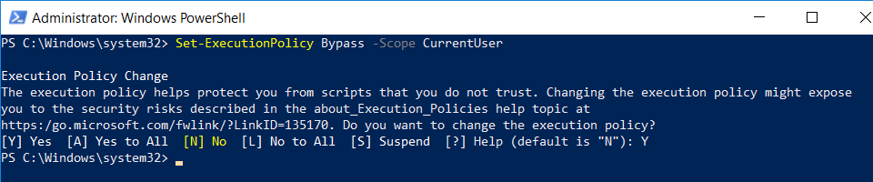

Install the Azure AD PowerShell Modules
In this task you will install the PowerShell libraries required to work with Microsoft Azure resources.
NOTE: if you are running Windows 8.1, you must first install the Windows Management Framework 5.1 which is covered in step 1 below. If you are running Windows 10, you can skip step 1 and move to step 2 below.
- If you are running Windows 8.1, download and install the Windows Management Framework 5.1using the following link.
https://www.microsoft.com/en-us/download/details.aspx?id=54616
- Install the Azure PowerShell modules by executing the following PowerShell commands one at a time in the PowerShell console.
  - In the PowerShell console, execute the following command
Install-PackageProvider -Name NuGet -MinimumVersion 2.8.5.201 -Force
  - Next, execute the following command to trust the PowerShell gallery.
Set-PSRepository -Name PSGallery -InstallationPolicy Trusted
  - Next, execute the following command to install the Azure Resource Manager (RM) PowerShell cmdlets library.
Install-Module AzureRM -AllowClobber -Force
  - Next, execute the following command to install the Azure Active Directory PowerShell cmdlets library.
Install-Module AzureAD -AllowClobber -Force
  - Finally, execute the following command to install the Power BI cmdlets library.
Install-Module MicrosoftPowerBIMgmt -Force

Install the GIT CLI Utility
In this exercise, you will install the git utility.
- Launch a browser and navigate to the following link.
https://git-scm.com/download
- Download the installation files for git for Windows.
- Run the installation program. When prompted, agree to the terms and accept all the default settings.
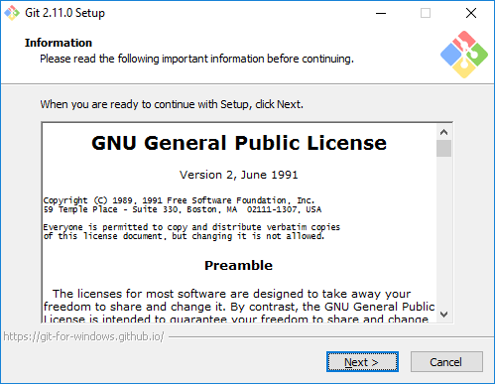
- Wait until the installation is complete.

Install Visual Studio 2017
In this exercise, you will install Visual Studio 2017 Professional. Note if you don't have access to Visual Studio 2017 Professional, you can complete all of the labs instead using the free version of Visual Studio 2017 community edition.
- Obtain the installation software for Visual Studio 2017 Professional.
  - If you don't have a copy, you can download the Visual Studio 2017 community edition using the following link.
https://visualstudio.microsoft.com/thank-you-downloading-visual-studio/?sku=Community&rel=15
- Click Continue to run the installation program for Visual Studio 2017.
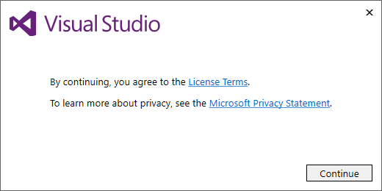
- Under Workloads tab in the Windows section, select the following workloads
  - Universal Windows Platform development (this is optional)
  - .NET desktop development (this is required)
- Under Workloads tab in the Web and Cloud section, select the following workloads
  - Web development (this is required)
  - Azure development (this is required)
  - Node.js development (this is optional)
  - Data storage and processing (this is optional)
  - Office/SharePoint development (this is optional)
- Move ahead in the installation program to the Summary section. Locate and click the Install button in the bottom right corner to begin the installation.
- Instalation will take about 20-30 minutes. When the installation is complete, you will see the a page telling you that Visual Studio 2017 has been installed.
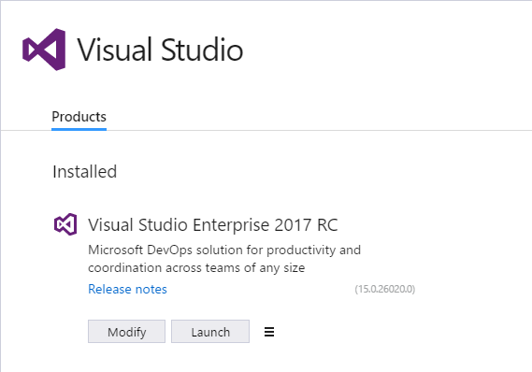
- Launch Visual Studio 2017.
  - When you see the Welcome screen, it will prompt you to sign into Visual Studio Online. However, there is no need for you to log onto Visual Studio Online. Instead, click the Not now, maybe later link at the bottom of the Welcome screen
  - On the next screen, select a Development Setting for the color theme and then click Start Visual Studio.
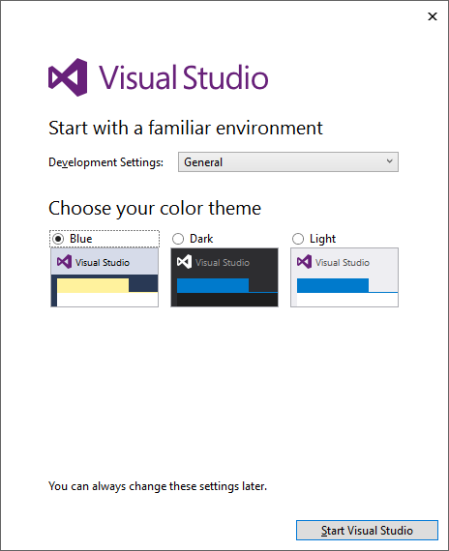
  - Once Visual Studio has started, select the File > New Project command.
  - On the left hand side of the New Project dialog, select Installed > Templates > Visual C# > Office/SharePoint.
  - Make sure you see the SharePoint Add-in project template. If you see the SharePoint Add-in project template, it means you have installed Visual Studio 2017 with the Office/SharePoint toos.
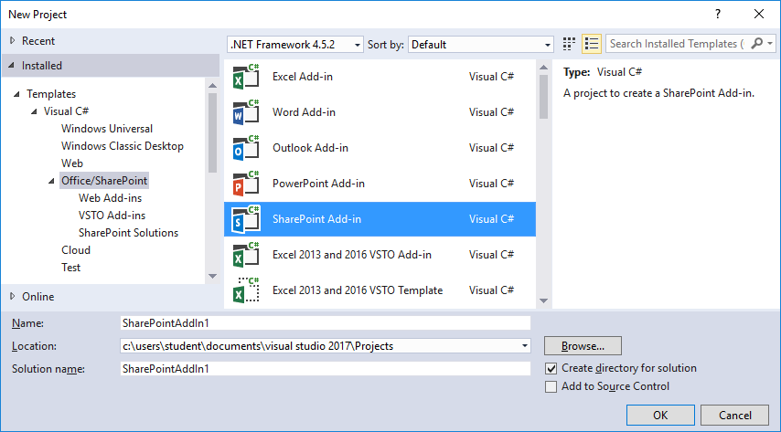

Install Fiddler
In this exercise, you will install the Fiddler developer utility.
- Launch a browser and navigate to the following link.
https://www.telerik.com/download/fiddler
- Download the installation files for Fiddler.
- When the Fiddler installation program starts, it prompts you to accept the licensing agreement. Click I Agree.
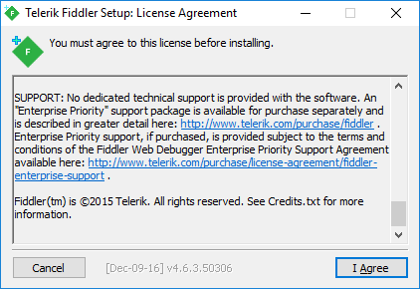
- Next, click the Install button to run the Fiddler installation program.
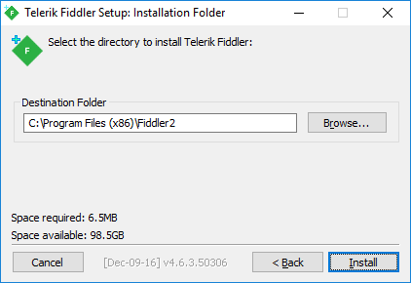
- When the Fiddler installation program completes, launch Fiddler from the Windows Start menu.
Steps 6, 7 and 8 only apply if you are using Windows 10. If you are using Windows 8.1, you can skip ahead to step 9.
- When Fiddler starts for the first time, it prompts you with the AppContainer Configuration dialog. Click the Cancel button to dismiss the dialog and prevent this dialog from reappearing later.
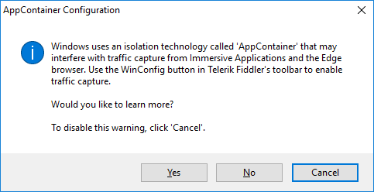
- Once Fiddler has started, click the WinConfig button in the toolbar in the top left-hand corner of the Fiddler window to display the AppContainer Loopback Exemption Utility dialog.
- In the AppContainer Loopback Exemption Utility dialog, select Microsoft Edge on the left and then click Save Changes.
- Configure Fiddler support inspecting HTTPS request that are using SSL.
  - Select the Tools > Options… command
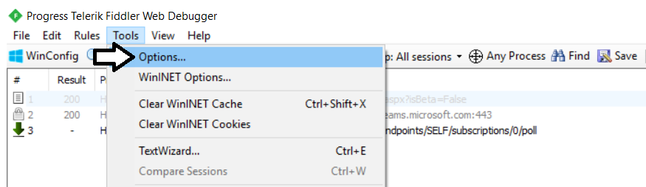
  - On the General tab of the Options dialog, uncheck the Notify me for updates on startup checkbox.
  - On the HTTPS tab of the Telerik Fiddler Options dialog, check the Decript HTTPS traffic checkbox.
  - Click Yes when prompted whether to Trust the Fiddler Root Certificate?
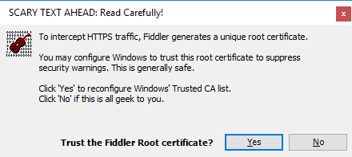
  - Click Yes, when you see the following dialog which asks Do you want to install this certificate.
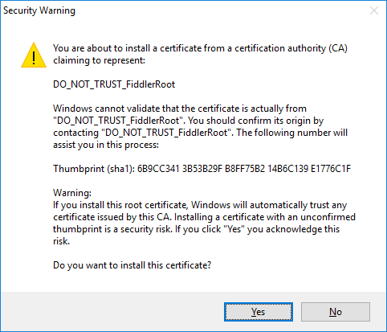
  - Click Yes one more time when you see the TrustCert Confirmation dialog.
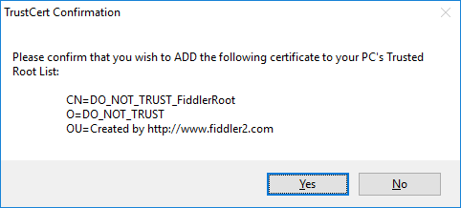
  - You should now see a dialog that confirms that Fiddler's root certificate has been added to the machine root list.
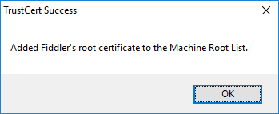
  - Select Ignore server certificate errors (unsafe) and then click OK to dismiss the Options dialog.
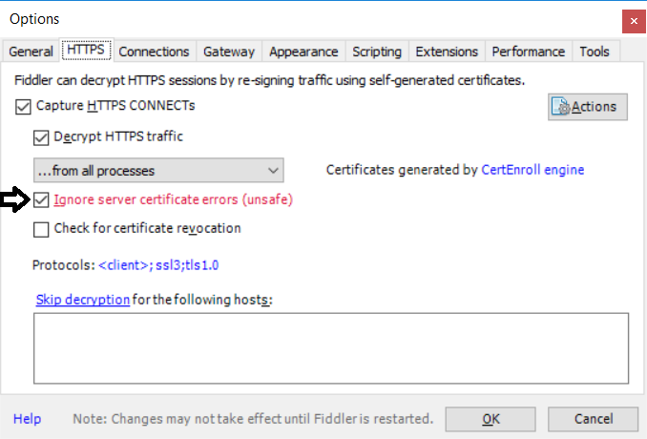
- Test out Fiddler.
  - Close and restart Fidler.
  - Launch the Chrome browser and navigate to a URL with SSL such as https://google.com.
  - Make sure you can use Fiddler to monitor HTTPS request.
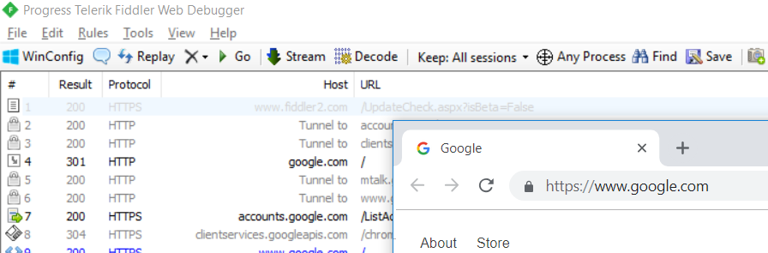
  - If you are using Windows 10, launch the Microsoft Edge browser and navigate to a URL with SSL such as https://bing.com.
  - Make sure you can use Fiddler to monitor HTTPS request.

Install Node.js Version 8.x
In this task, you will install Node.js version 8.x. The reason you will install version 8.x and not a more recent version as 9 and 10 is due to incompatibilities with the SharePoint Framework. If you have a more recent installation of Node.js with version 9 or version 10, it will work fine for all the labs and demos in this course except for those that involve Power BI embedding with the SharePoint Framework.
- Download the MSI file to install the latest release of Node.js version 8.
  - Navigate to the web page at the following URL..
https://nodejs.org
  - You should see a folder of files installation files similar to the folder shown in the following screenshot.
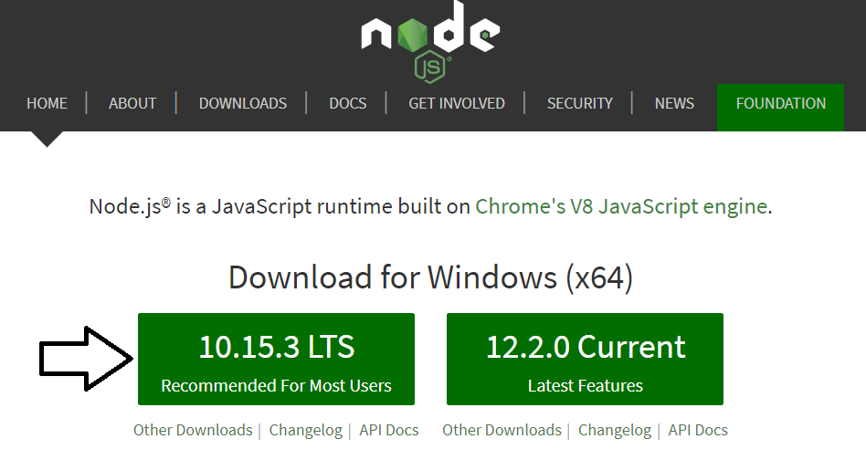
  - Click on the button to install the most recent LTS version of Node.JS.
  - Once you have downloaded node-v10.x.y-x64.msi, run it to begin the Node.js installation program.
  - When you see the Node.js Setup Wizard's Welcome screen, click Next.
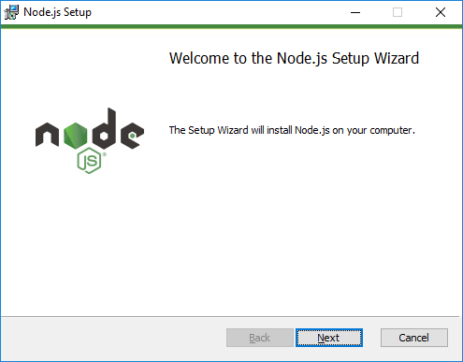
  - Agree to terms and click Next.
  - Accept (or modify) the installation folder and click Next.
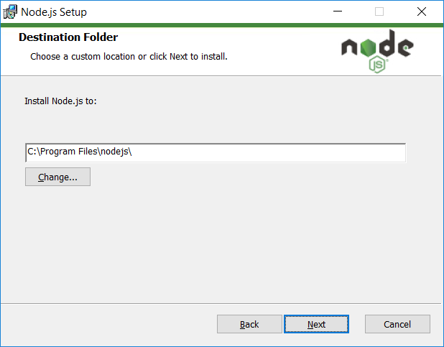
  - On the Custom Setup page, accept the default setting and click Next.
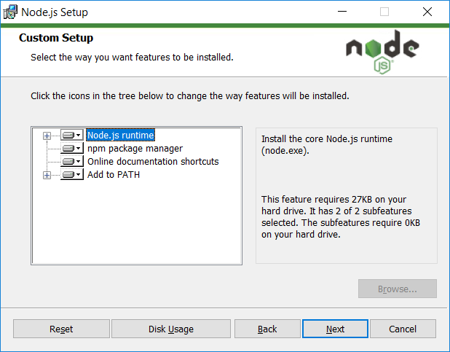
  - On the Ready to install Node.js page, click Install to begin the installation.
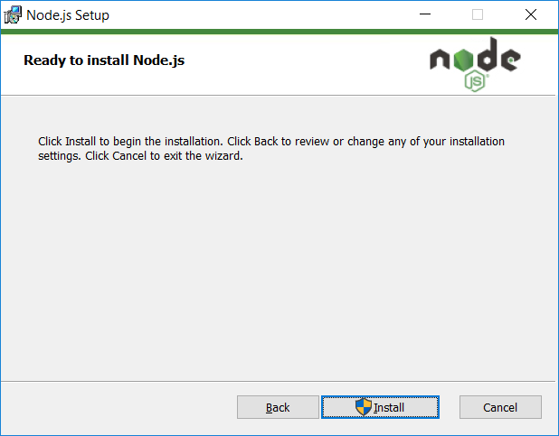
  - Wait until the installation completes and then click Finish.
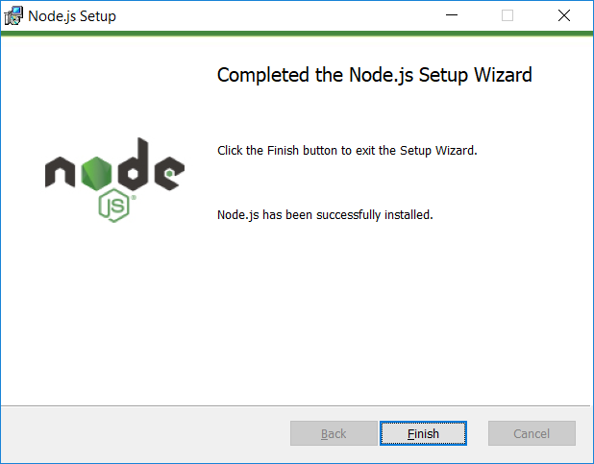
- Launch the Node.js command prompt.
  - In the Windows Start menu, locate and select the Node.js command prompt.
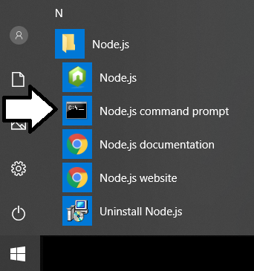
  - Verify the the Node.js command prompt launches without error and that the version number begins with an 8.
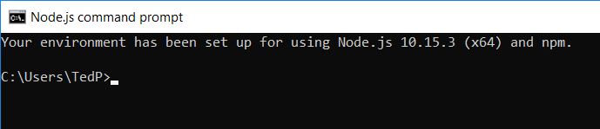

Install Visual Studio Code
In this setup task, you will install Visual Studio Code.
- Launch a browser and navigate to the following link.
https://code.visualstudio.com/download
- Download the installation files for Visual Studio Code for Windows.
- Run the installation program for Visual Studio Code.
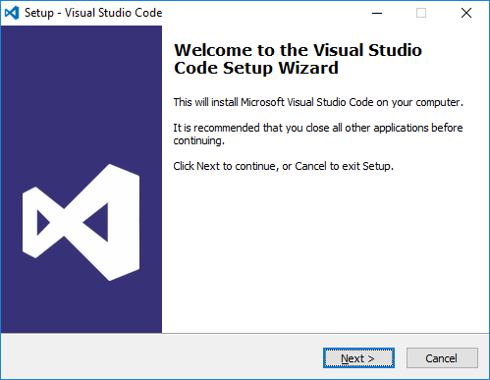
- When you get to the Select Additional Tasks dialog, select all options and click Next to continue.
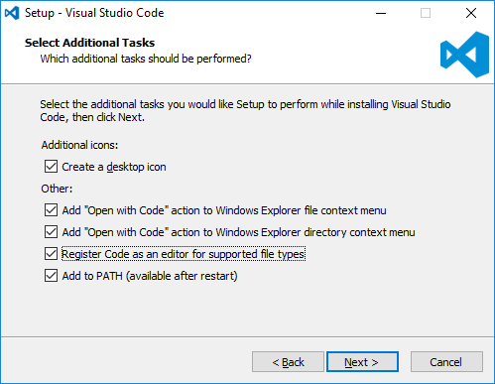
- When you get to the Ready to Install dialog, click Next to continue.
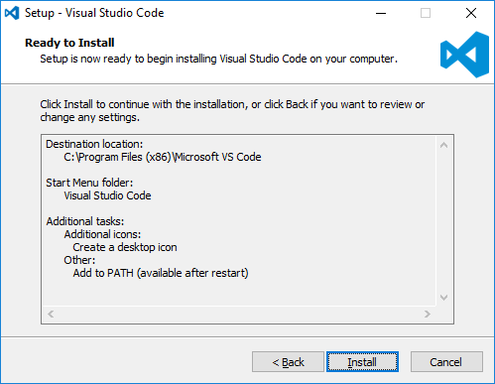
- Move through the dialogs of the installation program until you reach the Completing the Visual Studio Code Setup Wizard dialog. Click Finish.
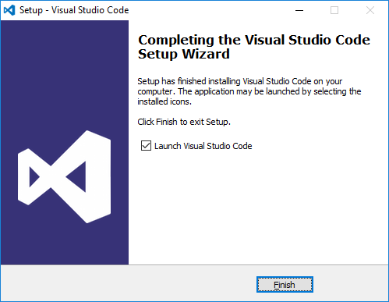
- When the installation program completes, it should launch Visual Studio Code.
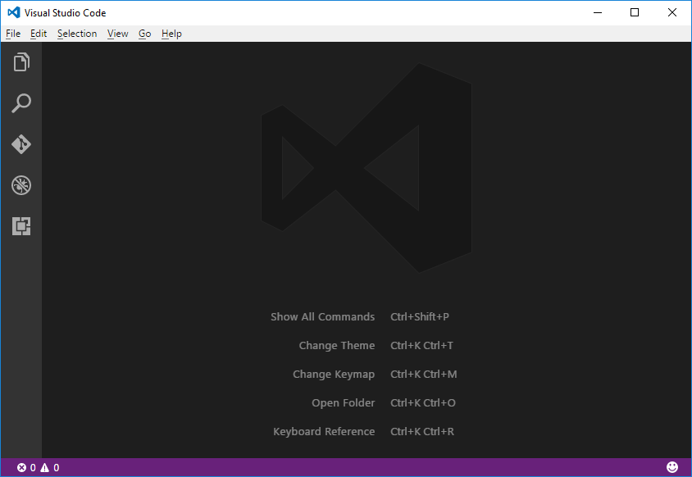
OK, that's it. You are all ready to begin the class and begin working on lab exercises.

